Kunri KCS Tuition Centre: Southern Sindh, Pakistan.

- This Tuition Centre is to meet the needs of poorer children going to school but not having the means to afford tuition.
- Kunri is located 6-7 hours drive from Karachi on the edge of the Thar Desert.
- This is a neglected area of the country with mostly a very poor rural population
Education changes lives and creates a future
The new School Rooms
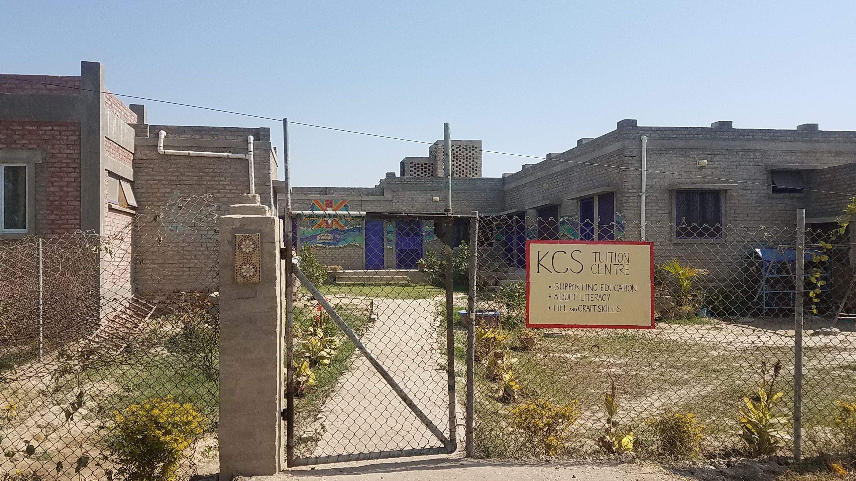
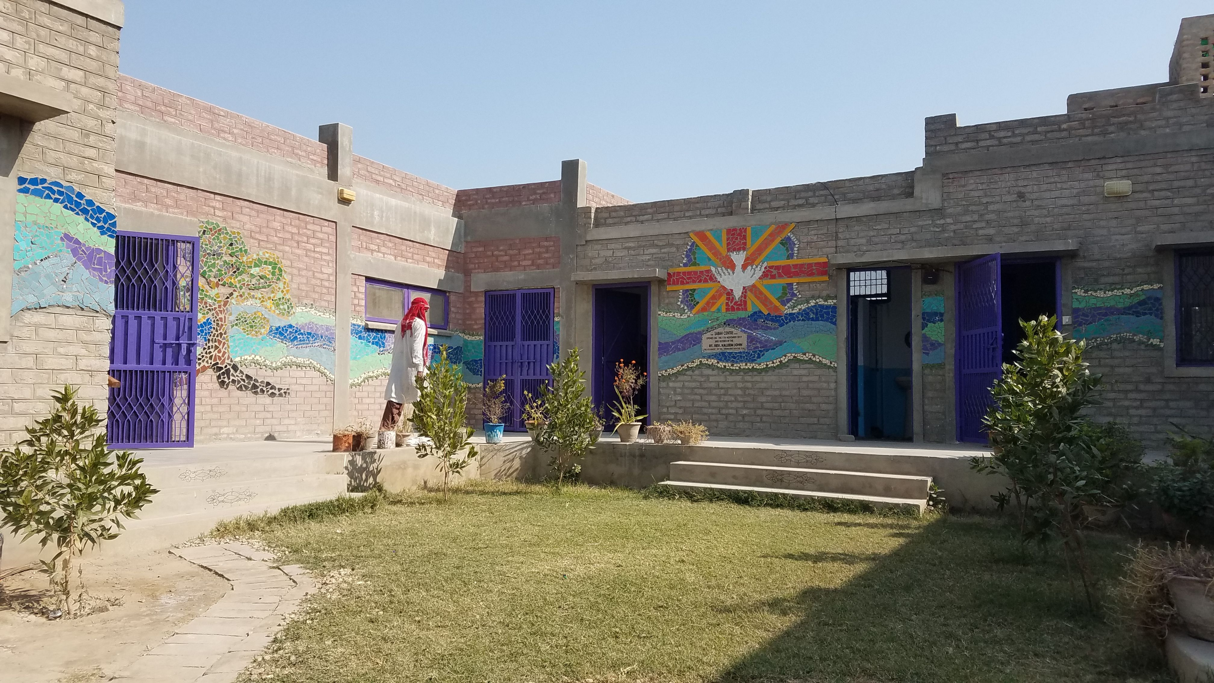
Newly Built Tuition Centre opened November 2019

In many countries, extra teaching is given in tutorials after school which supplement the income of the teachers. This is often core subject work or homework help. For poorer children, this ‘extra’ help is beyond their means and so they often fall to the bottom of the class.

The other issues for poor children include illiterate parents who can’t help at all. Families where the discipline of homework is not encouraged or understood and a lack of good space to work in. Space that has good lighting, power for fans in the hot weather, and a quiet environment to do efficient study in.
Internet access is also important these days. We provide tablets/computers for learning and games that teach. Online videos and other learning tools can be accessed from our facility free of charge.
The KCS Tuition Centre presently takes 45 children for after school tuition. We help with homework: but more importantly, plug the gaps of poor knowledge and strengthen their understanding of each subject.

“Joy for the pupils at the new Tuition Centre opening”
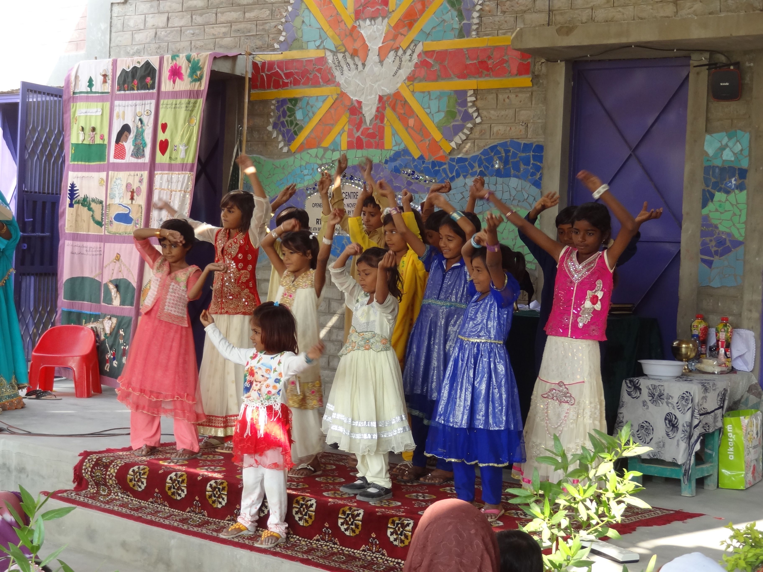
Since early March 2020 the facility has had to shut down as per government orders for educational facilities during the Covid 19 pandemic. Schools are set to begin again from mid-September. We too will open our doors at that time. Some students have been able to access internet and tablets with our help during the lockdown. Not all, unfortunately, were able to do so.

Parents and guests waiting for the opening of the new centre to begin.

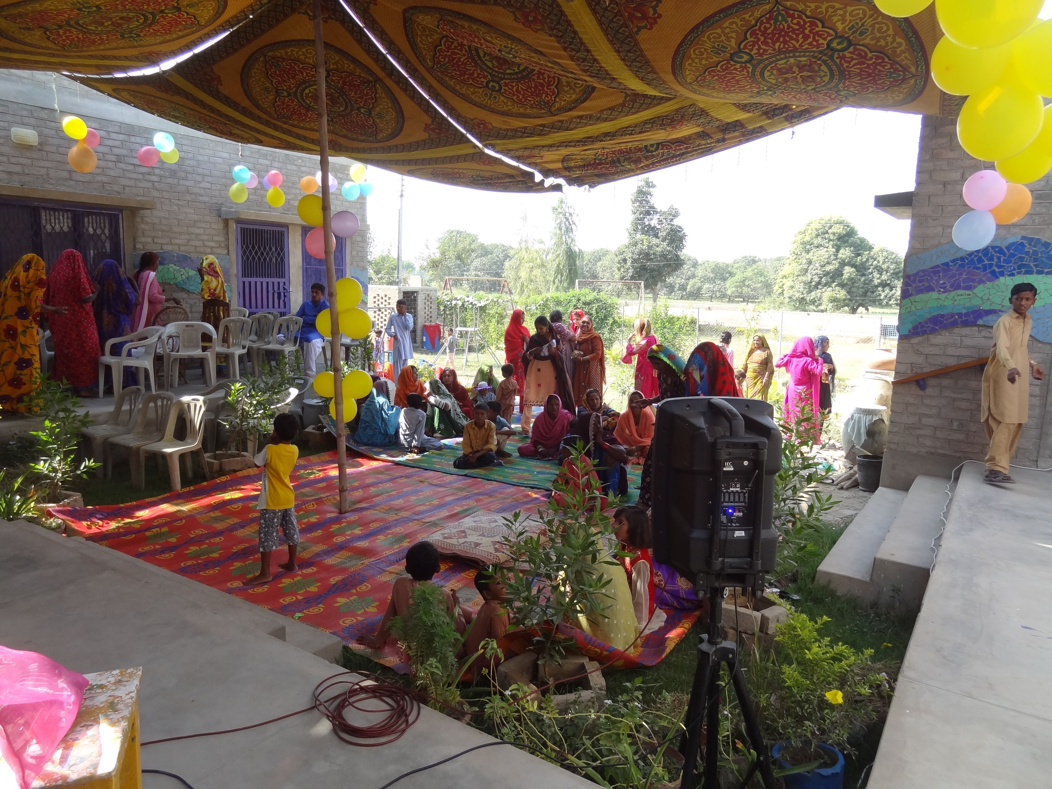

The role of the new building funded by EdAid has been invaluable. Without it we could not offer any help at all. The extra rooms mean the older students can go into quiet rooms for intense study. They can access the internet and have a comfortable work place far from the restrictions at home. Many report that coming to us means they are freed from household chores which would hinder homework being done or extra help accessed. It also disciplines them into getting their workload finished. All this increases their grades and confidence in the classroom.
If you could sponsor a student the costs are as follows.

A scholarship costs around $350 Per year for primary level,
$600 secondary and $1000 for local college level.
All Scholarships include books and school uniform

Email EdAid on edaidnz@outlook.com with any questions. Thank you for your support!

To donate to this wonderful project
Post your donation to:
EdAid
PO Box 4292
Whanganui 4541
New Zealand

Please make your cheque out to EdAid’ and include your name and address in the envelope so we can acknowledge your donation by
sending you a thank you letter and official tax receipt or email edaidnz@outlook.com the same

Donate via internet banking:
EdAid bank account number: 01-0790-0150782-26

Please include your name and the name of the project you wish to support as a reference. E-mail edaidnz@outlook.com with your Address

